- Git File Lifecycle (Stages)
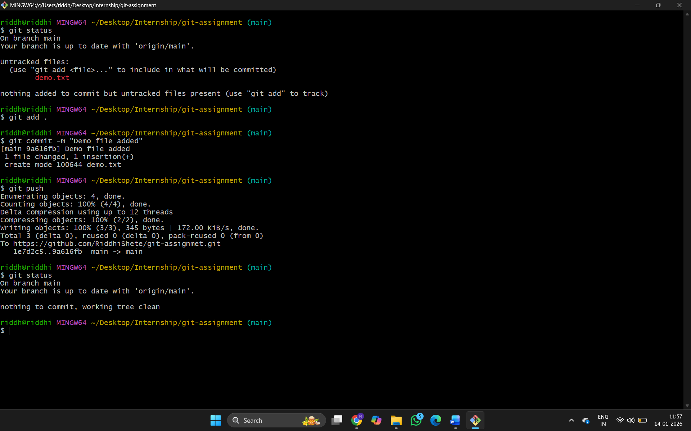

- Add collaborator to repository :
- Open the repository
- Go to settings
- Click on Collaborators
- Then Add people
- Enter the collaborator’s Github username or email
- The Collaborator gets an invite via email, which he must accept.

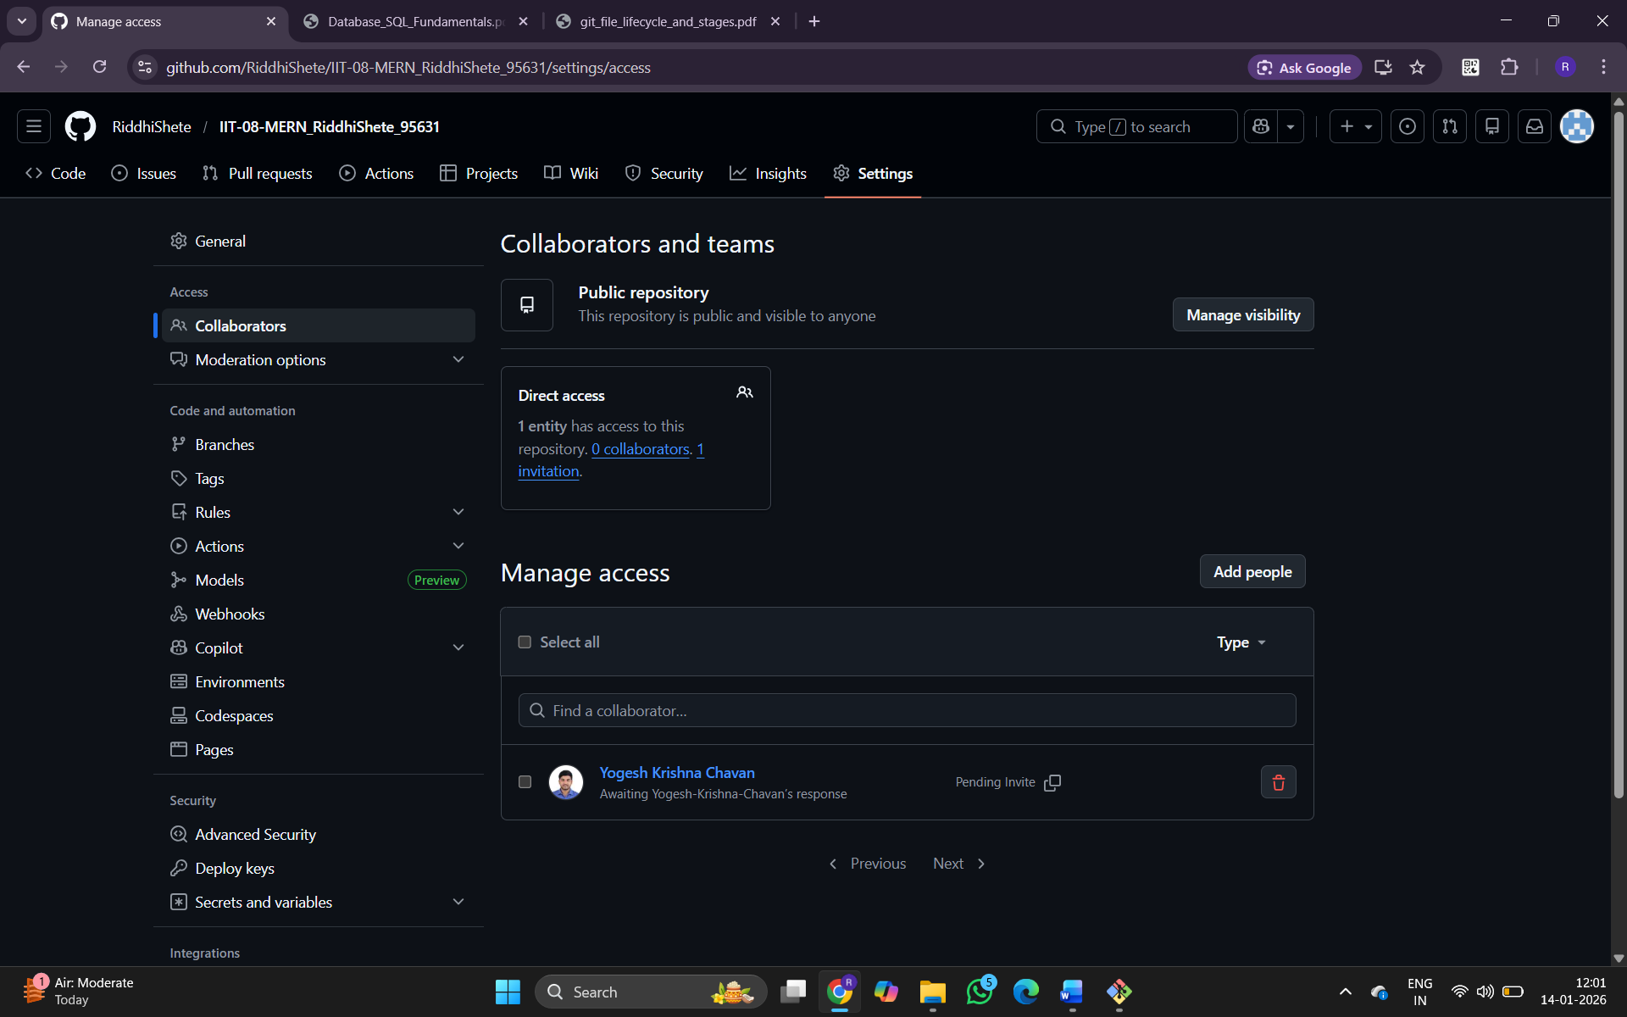
3. Branching commands :
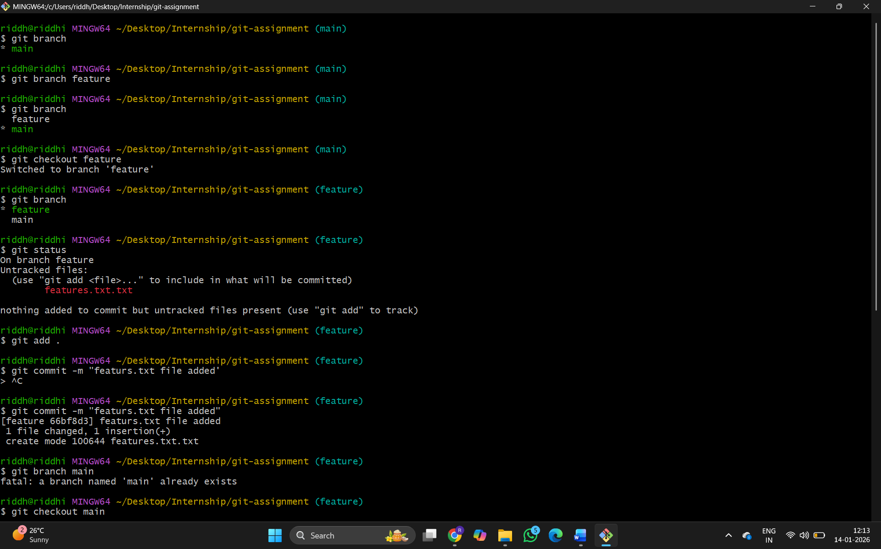
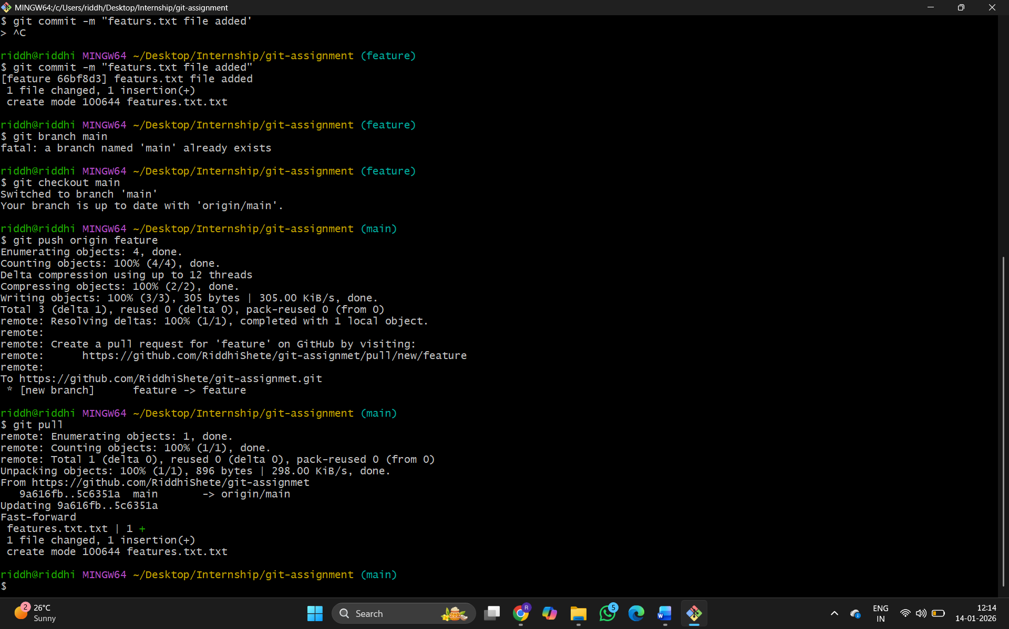

- Multi users and conflict resolution :
